Overview

Background:

ICANSCAN is a project sponsored by the Pediatric Neurologist, Dr. M. Golomb at Riley Hospital For Children At Indiana University Health located in Indianapolis, Indiana. The project is about the Magnetic Resonance Imaging (MRI) procedure, which is a medical imaging procedure for making images of the internal structures of the body. (<https://www.fda.gov/Radiation-EmittingProducts/RadiationEmittingProductsandProcedures/MedicalImaging/MRI/default.htm>).

Problem Statement:

The MRI procedure is loud and requires the patient to be still for the complete duration which varies between 20 minutes to 90 minutes. This makes the children nervous, scared and fidgety and if the scans aren’t accurate, the procedure is repeated, which costs the parents thousands of dollars again.   
Due to this fear and lack of awareness, the children and parents opt for anesthesia for the procedure. Although safe, anesthesia should not be the preferred choice for parents as it is not needed for this procedure as well as it delays the diagnosis and the treatment.   
The statistics show the number of MRI units owned country-wise for 6 countries. This shows that there is a high demand for MRI scans, making the above a serious problem.

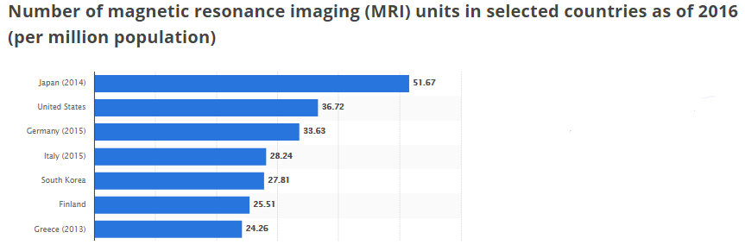

Solution:

The team felt that informing the parents and children about the procedure and about what to expect might reduce their fears. Therefore, we designed and developed an interactive VR application for children and an interactive iPad website for the parents to prepare them for the procedure. This would lead them to make an informed decision about the anesthesia, instead of a decision out of fear.

My Role:

This project was a team effort. I was the designer for the project and worked along with a VR developer. As the designer, I designed the VR app and the iPad website. I also developed the iPad website.

Duration:

2 years

Steps:

Understanding the problem

Persona

Low-fidelity sketches

Hi-fidelity prototype

User testing

Re-design

Next steps

Tools used:

Pencil and Paper

Sketch

Unity

VS Code, PHPStorm

iPad

VR Glasses

1. Understanding the problem

Our client, Dr. Golomb has been working with children for many years. Through her 24+ years of experience we understand that MRI can be scary for children due to the loud noise and restriction of movement.

My teammate and I tried the MRI for 15minutes each to empathize with a young child.

1. Persona  
   Our persona was decided by the client as a child between the age 3 years to 15 years who is required to take an MRI exam. Keeping this in mind, we began to think about ways to make our solution acceptable and fun to play with for the young children.

Our second persona was of a parent. We wanted the parent to see what the child is seeing in the interactive VR application and inform them about the details of the procedure.

1. Prototype

The final prototype took many iterations. The final iteration is:

* Interactive VR
* Interactive Website

1. Development

After designing, I developed the website in

* HTML
* CSS
* Javascript

1. User testing

I interned with Riley Physicians under Dr. Golomb in summer 2017 to conduct a IRS approved user test of the project. I was given the responsibility to observe, demonstrate and guide the users during their user testing.

I interviewed 96 participants (45 children and 51 parents/guardians) and recorded their reviews.

The test protocol was:

* Describe the project and make the patient comfortable
* Sign consent forms
* Let the users play around with the iPad and the VR headset
* Observe them while they intuitively click on the applications (Fly-on-the-wall obervations)
* Ask them questions as they play with the applications (Semi-structured interview)
* Conduct a small final questionnaire to get the user’s feedback (Formal interview)

The Questionnaires were:

Some feedback:

1. Re-design

Based on the feedback, I redesigned the screens.

Feedback and changes:

1. Next steps

This project is still in development. In the next phase we will

* Develop the new design
* Test it with patients
* Write a research paper on it